**FORM A1**

# **STUDENT PLAGIARISM DISCLAIMER FORM**



PLAGIARISM DISCLAIMER

STUDENT NAME: Raphael Salaja

STUDENT NUMBER: A00269349

PROGRAMME: BSc (Hons) in Software Design with Virtual Reality and Gaming

YEAR: 1

MODULE: Communications

LECTURER: Dr. Mairéad Seery

ASSIGNMENT TITLE: Assignment II: Group Project (30%)

DUE DATE:

DATE SUBMITTED:

ADDITIONAL INFORMATION:

I understand that plagiarism is a serious academic offence, and that AIT deals with it according to the AIT Policy on Plagiarism.

I have read and understand the AIT Policy on Plagiarism and I agree to the requirements set out therein in relation to plagiarism and referencing. I confirm that I have referenced and acknowledged properly all sources used in preparation of this assignment. I understand that if I plagiarise, or if I assist others in doing so, that I will be subject to investigation as outlined in the AIT Policy on Plagiarism.

I understand and agree that plagiarism detection software may be used on my assignment. I declare that, except where appropriately referenced, this assignment is entirely my own work based on my personal study/or research. I further declare that I have not engaged the services of another to either assist in, or complete this assignment.

Signed: Raphael Salaja

**Dated:**

Your reflective report should have an introduction (50 words)

# Write approx. 150-200 words:

Report the experience (What happened? What did the group project involve?)

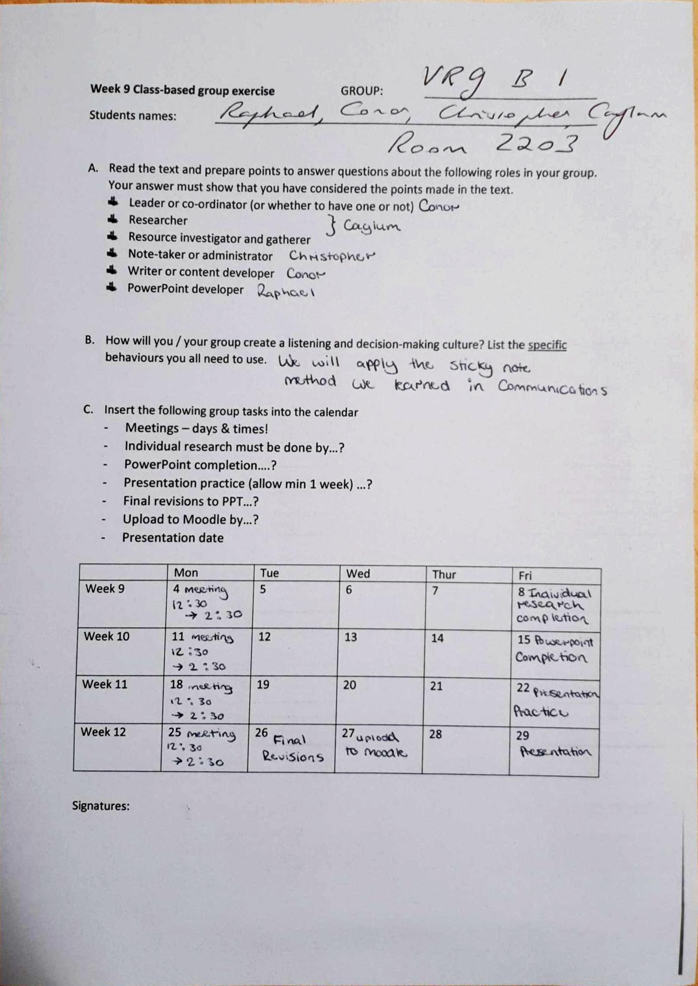

Figure 1: The timetable we used during the four weeks

The group project involved a lot of parts. First, we constructed a timetable, which would be our plan of attack for the four weeks. We decide on the days we would meet to discuss how each one of us was coping with our assigned tasks, as seen in Figure 1. We also assigned deadlines for tasks to be completed. This allowed us to leave time for practicing the presentation. The final part was to present the presentation to our lecturers

React to the experience / topic on an emotional level (*How did / do you feel?)*

The past four weeks will be an experience I will never forget. There were many high points and low points in my journey. Firstly, I will start with the positive points in my experience.

Firstly, the project allowed me to craft better friendships with my colleges who I will be working with in my time her in AIT. This made me feel content with my group as this led to us being able to work together with less tension.

However, there was low points in my experience. Making sure that everyone was on the same page was a problem at the early stages of our group work. This made me feel irritated as it caused setbacks in our journey.

Relate the experience / topic to a previous experience (*Can you compare this to something else?*)

The experience was very similar to an agile methodology presentation, I had to give with my group recently. In that experience had to go through the same difficulties I went through in this assignment, that is, making sure that everyone was on the same page and people not putting in equal amounts of work.

# Write approx. 300-400 words:

Reason / analyse the experience with reference to specific examples / points (*Why did it happen this particular way?) What was good / bad about that?*)

In my opinion, I fell as though these problems happened as a result of conflict of personalities and difficult group dynamics. According to Chivers & Shoolbred (2007)

“Individual personalities can be the cause of problems when overpowering leaders can have too much influence on the final presentation, or with members, who procrastinate yet do not complete what they are responsible for. “

In groups, there will always be a mix of egos and personalities. These conflicts create a misunderstanding and unneeded tension in the group which will cause the problems that I have outlined before. As someone who is very passionate about their work, engaging in collaborative work for me can be very hard. This is because working with others who do not put the same effort into a piece of work as I might can cause conflicts in the group which would lead to a poorly functioning team.

Reconstruct for the future (If you find yourself in a similar situation in the future, what will you do differently?)

In the future if I find myself in a similar functioning team, I will try to “Everyone on the Same Page” Policy that Devra Gartenstein outlined on his webpage (Gartenstein, 2019). He says that

“When everyone on a team knows what they're trying to achieve, it's much easier to get on the same page to achieve it”

Here he outlines that proper communication leads to well-functioning group. I feel as though our group may have lacked this which would have caused some misunderstanding in the group. To fix this, in the future I will make it my main goal to ensure that there is good communication between members. I will do this by organizing more meetings in the group. According to Monash University Library (2019) the main points involeved to hold productive meetings are to:

“Make sure everyone knows the goal of the meeting, and what to bring. Have a leader to keep the meeting on track. Have a note-taker to record decisions.”

The benefits of doing this are that everyone the team will be able to work on the same page, everyone can have a say in the direction of the project and that everyone will be held accountable for their own work. In my opinion this will help me and the groups I will be in, in the future to work together more efficiently

# References

Chivers, B., & Schoolbred, M. (2007). *A Student's Guide to Presentations : Making your Presentation Count* (1 ed.). SAGE Publications.

Gartenstein, D. (2019). *Factors That Promote Effective Teamwork*. Retrieved November 28, 2019, from <https://smallbusiness.chron.com/factors-promote-effective-teamwork-1932.html>

Monash University Library. (n.d.). *Working in groups and teams*. Retrieved November 29, 2019, from thebalancecareers: [https://www.monash.edu/rlo/study-skills/learning-at-university/working-in-groups-and-teams](%20https:/www.monash.edu/rlo/study-skills/learning-at-university/working-in-groups-and-teams)